Branching Strategy
1. Git Flow
- Branches:
  - Main: The stable branch for production-ready code.
  - Develop: An integration branch for features.
  - Feature Branches: Created from develop for individual features.
  - Release Branches: Created from develop to prepare for a release.
  - Hotfix Branches: Created from main to quickly fix production issues.
- Workflow:
  - Feature branches are merged into develop.
  - When ready, develop is merged into a release branch, then into main for deployment.
2. How you take measures for the security of the API (Authentication and Authorization)
Ensuring the security of an API involves implementing robust authentication and authorization measures. Here are some key practices:
1. Authentication
- Use OAuth 2.0: Implement OAuth 2.0 for token-based authentication, allowing third-party applications to access your API securely.
- API Keys: Generate unique API keys for each client. Ensure that keys are kept secret and are regenerated regularly.
- JWT (JSON Web Tokens): Use JWTs for stateless authentication. They can carry user identity and claims securely, and can be signed to prevent tampering.
- Multi-Factor Authentication (MFA): Implement MFA to add an extra layer of security during the authentication process.
2. Authorization
- Role-Based Access Control (RBAC): Define roles and permissions for users. Ensure that users can only access endpoints and resources relevant to their roles.
- Scope-Based Access: For OAuth, define scopes that limit what resources a user can access based on their permissions.
- Claims-Based Access: Utilize claims in JWTs to determine access levels, ensuring that users have the necessary permissions for specific actions.
3. Rate Limiting and Throttling
- Implement rate limiting to prevent abuse of your API by restricting the number of requests a user can make in a given time frame.
- Use throttling to slow down or temporarily block requests from users who exceed usage limits.
4. Input Validation and Sanitization
- Validate and sanitize all inputs to prevent injection attacks, such as SQL injection or cross-site scripting (XSS).
- Use whitelisting for acceptable input formats and types.
5. Transport Security
- Use HTTPS: Ensure all API communications are over HTTPS to encrypt data in transit.
- HSTS: Implement HTTP Strict Transport Security to enforce secure connections.
6. Logging and Monitoring
- Log API access and errors to monitor for suspicious activity.
- Implement alerts for unusual patterns of access or potential breaches.
7. CORS (Cross-Origin Resource Sharing)
- Configure CORS policies to restrict which domains can access your API, mitigating cross-origin attacks.
8. Regular Security Audits and Penetration Testing
- Conduct regular security assessments to identify vulnerabilities.
- Engage in penetration testing to simulate attacks and evaluate the robustness of your security measures.
9. Documentation and Best Practices
- Provide clear API documentation for developers, emphasizing secure usage.
- Educate your team about secure coding practices and the importance of security in API development.
3. why we use specific exception and generic exception
Using specific exceptions and generic exceptions in programming helps manage errors more effectively. Here’s why each is important:
Specific Exceptions
- Precision: Specific exceptions provide clear information about the type of error that occurred (e.g., FileNotFoundException, InvalidInputException). This allows developers to understand the context of the error immediately.
- Granularity in Handling: You can catch and handle specific exceptions differently. For example, if a file is missing, you might want to log an error and prompt the user for a new file path, while a database connection failure might trigger a retry mechanism.
- Improved Debugging: When an exception is thrown, having a specific type makes it easier to diagnose issues during debugging. You can quickly pinpoint where and why the failure occurred.
- Encapsulation of Related Errors: Specific exceptions can encapsulate related error conditions, making it easier to manage and document expected failure cases.
Generic Exceptions
- Catch-All: Generic exceptions (like Exception or Throwable in some languages) serve as a catch-all for unexpected errors that might not be covered by specific exceptions. This can prevent crashes and allow for graceful degradation of functionality.
- Fallback Mechanisms: They enable fallback handling strategies. If something goes wrong that isn’t anticipated, you can log the error, notify developers, and potentially recover from it without terminating the application.
- Simplified Error Handling: In certain scenarios, it may be impractical to handle every possible specific exception. A generic exception can simplify error handling when a broad approach is sufficient.
- Separation of Concerns: By catching specific exceptions first and then a generic one, you can separate expected error conditions from truly exceptional cases, improving the overall structure of error management.
4. How do you make sure the code is clean
Ensuring that code is clean is essential for maintainability, readability, and collaboration. Here are some best practices to achieve clean code:
1. Follow Coding Standards
- Style Guides: Adhere to language-specific style guides (e.g., PEP 8 for Python, Google Java Style Guide).
- Consistent Naming Conventions: Use meaningful and consistent names for variables, functions, and classes.
2. Write Clear and Concise Code
- Simplicity: Strive for simplicity. Avoid unnecessary complexity in your code.
- Single Responsibility Principle: Each function or class should have a single purpose or responsibility.
3. Comment Judiciously
- Explain Why, Not What: Comments should explain why certain decisions were made, not what the code does (which should be clear from the code itself).
- Document Assumptions: Note any assumptions made in the code for future reference.
4. Organize Code Logically
- Structure: Group related functions and classes together in files or modules.
- Clear Project Structure: Follow a logical folder structure for easy navigation.
5. Refactor Regularly
- Continuous Improvement: Regularly review and refactor code to improve its structure and readability.
- Remove Dead Code: Eliminate unused or redundant code to keep the codebase clean.
6. Limit Line Length
- Readability: Keep lines of code reasonably short (generally around 80-120 characters) to enhance readability.
7. Use Version Control
- Git or Similar Tools: Use version control systems to track changes, enabling easier collaboration and rollback if necessary.
8. Automate Testing
- Unit Tests: Write unit tests to ensure code behaves as expected and to make future changes safer.
- Continuous Integration: Implement CI/CD pipelines to automate testing and ensure code quality.
9. Review and Collaborate
- Code Reviews: Regularly conduct code reviews to catch issues early and share knowledge among team members.
- Pair Programming: Collaborate in real-time with another developer to share best practices and improve code quality.
10. Use Linters and Formatters
- Automated Tools: Use linters and code formatters (e.g., ESLint for JavaScript, Prettier, Flake8 for Python) to catch style issues and enforce consistency.
11. Document Your Code
- Documentation: Maintain up-to-date documentation that explains the architecture, APIs, and key components of your codebase.
12. Adopt Design Patterns
- Use Established Patterns: Leverage design patterns that promote clean architecture and help solve common design problems.
5. What are solid principles
SOLID is an acronym representing five design principles intended to improve the design, maintainability, and scalability of software. Here’s a breakdown of each principle:
1. S - Single Responsibility Principle (SRP)
A class should have one and only one reason to change, meaning it should have only one job or responsibility. This leads to better organization and makes the system easier to understand and maintain.
2. O - Open/Closed Principle (OCP)
Software entities (classes, modules, functions, etc.) should be open for extension but closed for modification. This means you should be able to add new functionality without changing existing code, typically achieved through interfaces or abstract classes.
3. L - Liskov Substitution Principle (LSP)
Subtypes must be substitutable for their base types without altering the correctness of the program. In other words, if class B is a subclass of class A, objects of class A should be replaceable with objects of class B without affecting the program's behavior.
4. I - Interface Segregation Principle (ISP)
Clients should not be forced to depend on interfaces they do not use. This principle encourages the creation of smaller, more specific interfaces rather than a large, general-purpose one. This reduces the impact of changes and increases flexibility.
5. D - Dependency Inversion Principle (DIP)
High-level modules should not depend on low-level modules. Both should depend on abstractions (e.g., interfaces). Additionally, abstractions should not depend on details; details should depend on abstractions. This principle promotes loose coupling between components.

6. What is generator
In programming, a generator is a special type of iterable that allows you to create an iterator in a more efficient way than using a list or other collections. Generators provide a way to produce values on the fly and are particularly useful for working with large datasets or streams of data, as they allow you to iterate through values without loading everything into memory at once.
Key Characteristics of Generators:
- Lazy Evaluation: Generators compute their values on the fly, which means they generate items only as needed. This can save memory and improve performance, especially with large datasets.
- Yield Statement: Instead of returning a value using the return statement, generators use the yield keyword. When a generator function calls yield, it pauses its execution and returns the value. The function's state is saved, allowing it to resume from where it left off the next time it is called.
- Single Iteration: Generators can only be iterated once. Once the generator has been exhausted (i.e., all values have been yielded), it cannot be restarted or reused. However, you can create a new generator instance.
Advantages of Generators:
- Memory Efficiency: Since they yield one item at a time, they can handle large datasets without using significant memory.
- Cleaner Code: Generators can lead to simpler and more readable code compared to traditional iterator classes.
- Infinite Sequences: Generators can produce infinite sequences without running out of memory (as long as you have a way to stop iterating)

6. Difference between interator and generator
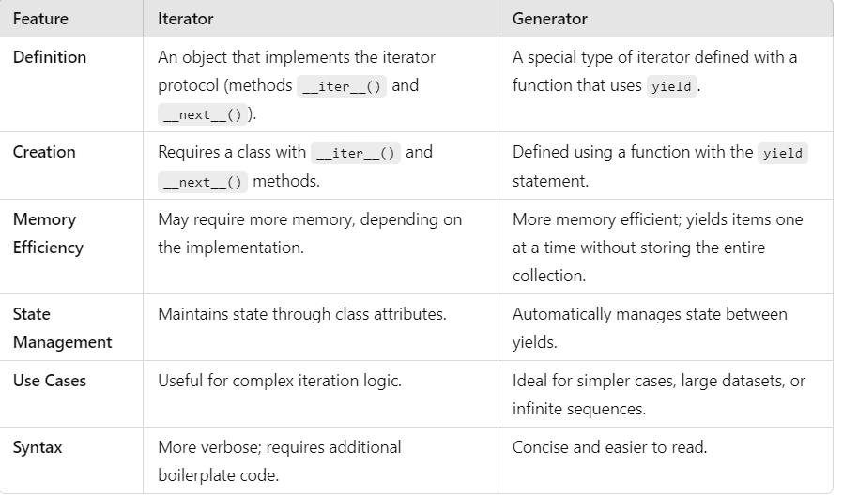

Difference between numpy and pandas
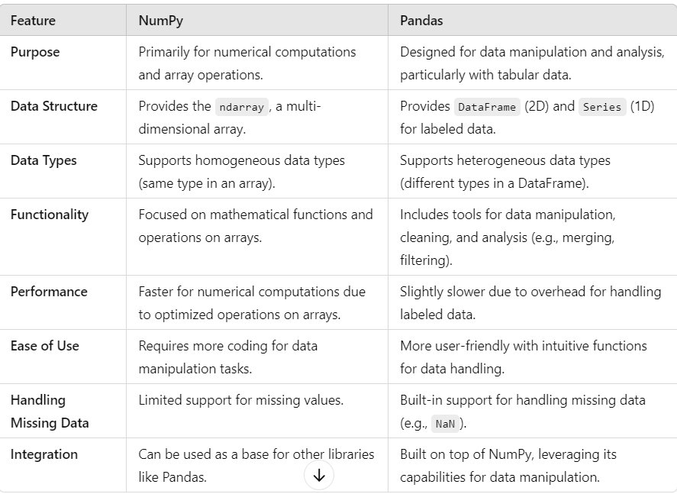

difference between github and gitlab
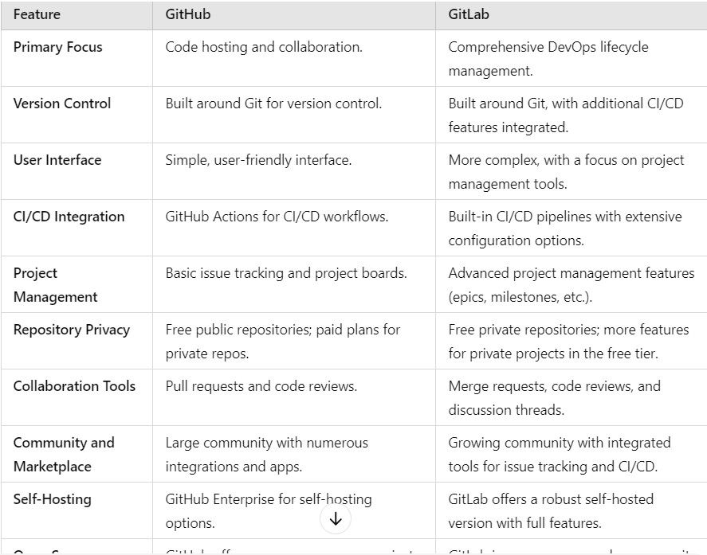

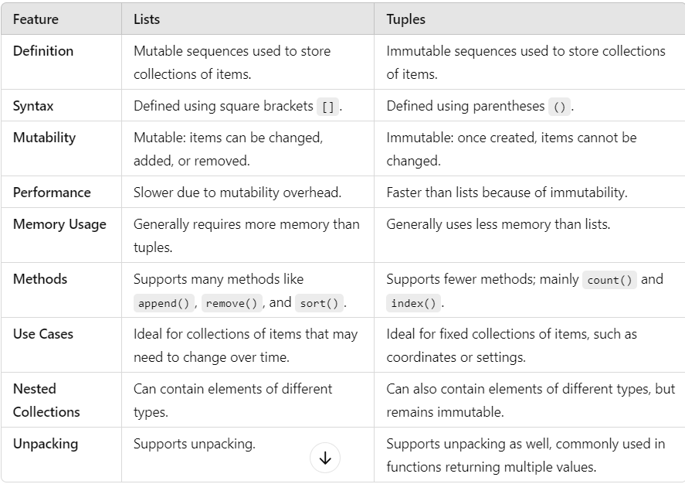
How does memory management work in Python?
Memory management in Python is a crucial aspect of how the language operates, ensuring that memory is allocated, used, and deallocated efficiently. Here’s an overview of how memory management works in Python:
1. Memory Allocation
- Dynamic Typing: Python uses dynamic typing, meaning that variable types are determined at runtime, and memory is allocated as needed.
- Memory Pools: Python maintains different memory pools for different data types (e.g., integers, lists). This allows for more efficient allocation.
2. Object Creation
- When a new object is created (e.g., a list or string), Python allocates memory for it in the heap.
- Each object in Python has an associated reference count that tracks how many references point to that object.
3. Reference Counting
- Garbage Collection: Python primarily uses reference counting for memory management. When the reference count of an object drops to zero (meaning there are no references to it), the memory occupied by that object can be reclaimed.
- This helps manage memory automatically, as Python can free up memory when objects are no longer in use.
4. Garbage Collector
- In addition to reference counting, Python has a garbage collector that identifies and collects cyclic references (where objects reference each other).
- The garbage collector runs periodically, cleaning up memory that cannot be freed through reference counting alone.
5. Memory Leaks
- While Python's memory management helps prevent leaks, they can still occur, often due to circular references or holding onto references longer than necessary.
- Tools like gc module and memory profilers can help identify and debug memory leaks.
6. Memory Management Modules
- Python includes built-in modules such as gc for interacting with the garbage collector and managing memory more explicitly when needed.
7. Memory Management Techniques
- Object Pooling: Reusing objects instead of creating new ones can reduce overhead.
- Weak References: The weakref module allows you to create weak references that do not increase the reference count, useful for caching or avoiding circular references.
Summary
- Python uses a combination of reference counting and garbage collection for memory management.
- Objects are allocated memory on the heap, and Python automatically manages memory through its internal mechanisms, reducing the programmer's burden.
- While Python handles memory well, understanding its workings can help in optimizing performance and preventing memory-related issues.
What is GIL
The Global Interpreter Lock (GIL) is a mechanism used in CPython, the standard implementation of Python, to ensure thread safety and memory management. It essentially allows only one thread to execute Python bytecode at a time, even on multi-core systems. Here’s a detailed discussion of the GIL and its implications:
What is the GIL?
- Purpose: The GIL was introduced to simplify memory management and ensure that memory allocation is thread-safe. It protects access to Python objects, preventing race conditions.
- Behavior: While threads can run in a Python program, only one thread can execute Python bytecode at any given time. This means that even on multi-core processors, Python threads cannot run in parallel on multiple cores.
Implications of the GIL
- Multithreading Limitations:
  - CPU-bound Operations: For CPU-bound tasks (tasks that require significant CPU time), the GIL can become a bottleneck. Multiple threads do not effectively utilize multiple cores, leading to suboptimal performance.
  - I/O-bound Operations: In contrast, for I/O-bound tasks (like network operations or file I/O), the GIL is less of an issue. While one thread waits for I/O operations, others can execute, allowing better performance in these scenarios.
- Performance:
  - Single-threaded Performance: The presence of the GIL can sometimes lead to better performance in single-threaded applications due to reduced context-switching overhead.
  - Parallel Processing: To leverage multi-core architectures for CPU-bound tasks, developers often use multiprocessing (spawning separate processes instead of threads), which bypasses the GIL since each process has its own Python interpreter and memory space.
- Complexity in Threading:
  - Design Considerations: The GIL requires developers to be more mindful when designing multi-threaded applications. For instance, CPU-bound operations may need to be split into separate processes rather than threads.
  - Third-party Libraries: Some third-party libraries, especially those that release the GIL (like NumPy when performing numerical computations), can still benefit from multi-threading for CPU-bound tasks.
- Alternatives:
  - Other Implementations: Other Python implementations, like Jython and IronPython, do not have a GIL and handle multithreading differently. However, they are not fully compatible with all Python libraries.
  - Future Directions: Discussions about removing or improving the GIL have been ongoing in the Python community, but any significant changes would require careful consideration of backward compatibility and performance.

What tools or libraries would you use for making HTTP requests?
